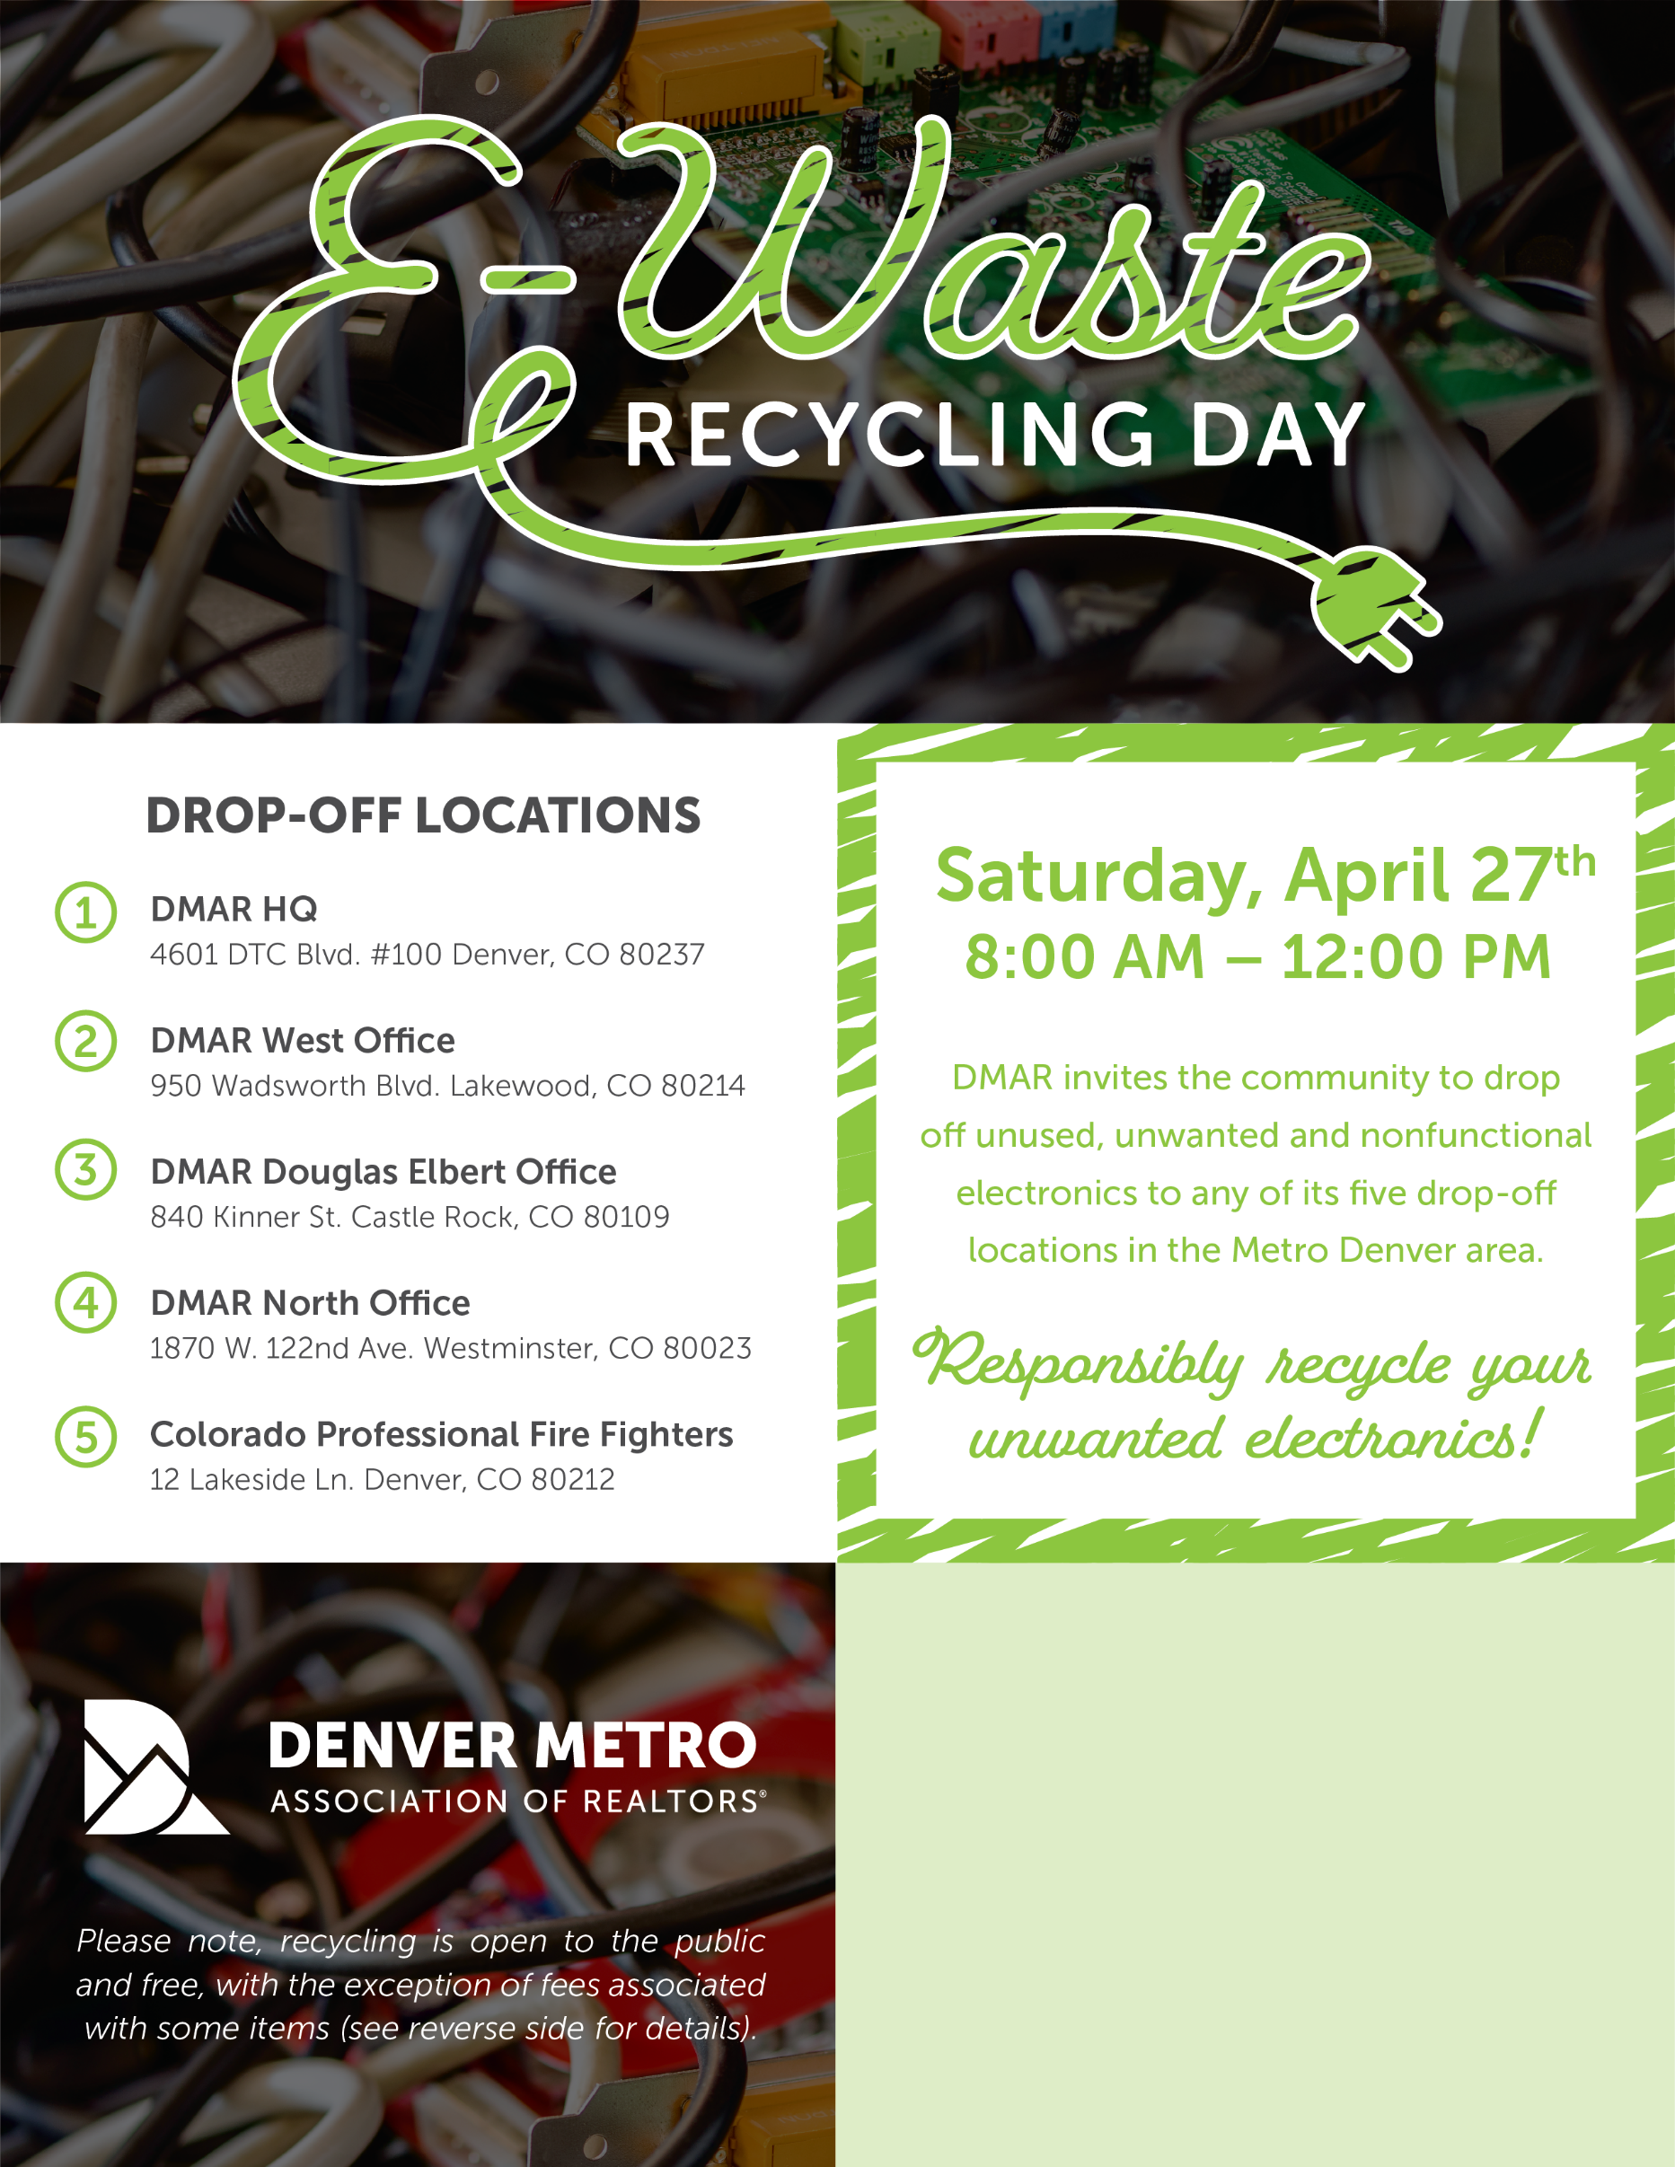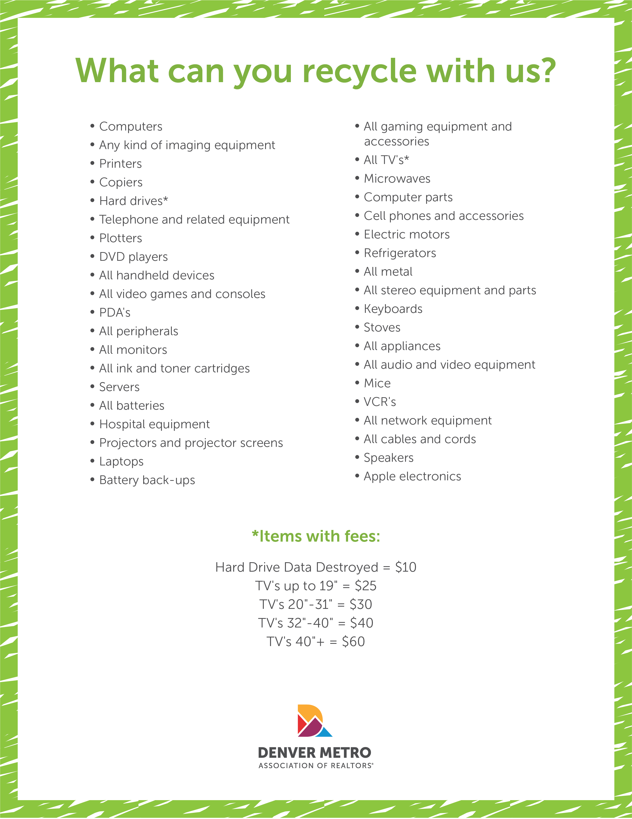

Invite your clients to participate in this event! Use this text box to add a personalized message. Feel free to insert a logo or headshot as well!