RPAC Gala: Night at the Museum

Wednesday, October 3 | 6:00 PM – 8:00 PM

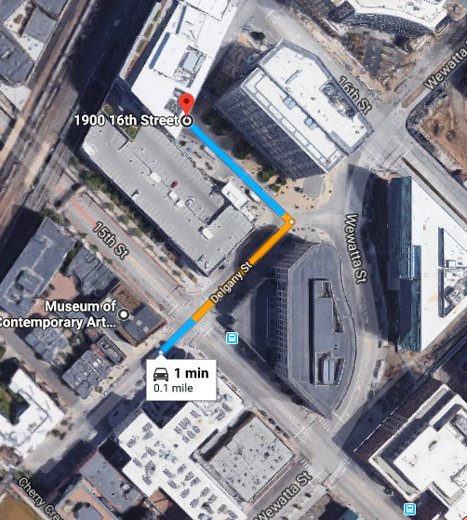
Museum of Contemporary Art, Denver
1485 Delgany St. Denver, CO 80202

FREE PARKING:
There is parking available in the DaVita building garage located at 1900 16th St, which is across 15th Street from the museum to the north.
Guests can park anywhere in the garage after 4:00 PM (even the spaces marked for tenants/residents).
You will get a ticket first, and parking vouchers will be distributed at the event.

